**CloudPlatform**



Self Service Desktops

Administration Guide

  
www.citrix.com

Introduction

This document describes how to administer the Citrix Self Service Desktops solution using the supplied Admin Tool, (an ASP.NET web application)

Overview

The Citrix Self Service Desktops Admin tool manages the configuration file of the Citrix Self Service Desktops Agent and will stop/start the Agent as required to make changes to that file.

Normally the configuration is located at C:\Program Files (x86)\Citrix\SelfServiceDesktops\Agent\Citrix.SelfServiceDesktops.Agent.exe.config but if you have installed the Agent to a different location the web app should locate the correct file.

Administrative privileges are required to use the Admin Tool – in particular you need to have write access to the configuration file and the privilege to start and stop Windows services.

Installation

The Citrix Self Service Desktops Admin tool is distributed as a standalone MSI file named

Citrix.SelfServiceDesktops.Admin.WebApp.Setup.msi and should be installed on the same server as the Citrix Self Service Desktop Agent, as it will be managing the configuration file of that Agent.

The Administration web app will install to http://<server>/Citrix/SelfServiceDesktopsAdmin and you will be presented with an option to start the web app once the installation has completed.

If it does not exist, create the folder C:\CtxLogs to enable the application to write diagnostic log entries.

Operation

The Admin tool uses Windows integrated authentication – which means you will not be presented with a conventional log in page but proceed directly to the home page of the application which is illustrated below

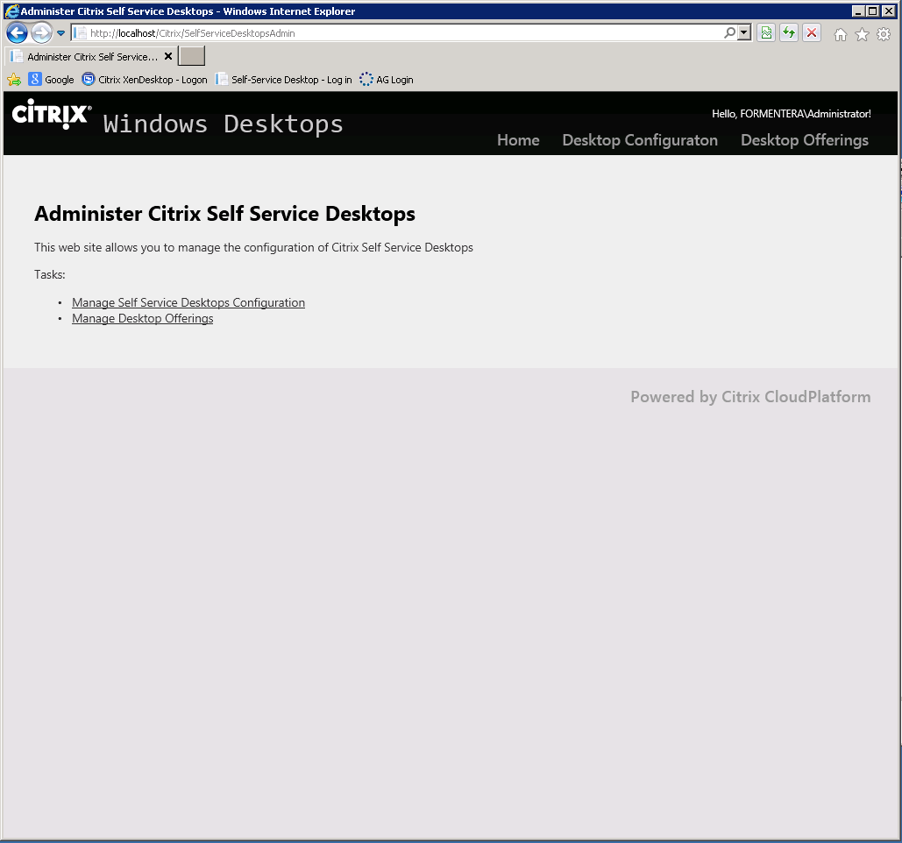

There are two options available:

1. Manage the general configuration options
2. Manage the Desktop Offerings.

General Settings

If you select the Manage Self Service Desktops Configuration option you wil be presented with an editor screen allowing you to edit the general configuration settings as shown below. You may also navigate to this page using the Desktop Configuration button on the header bar.

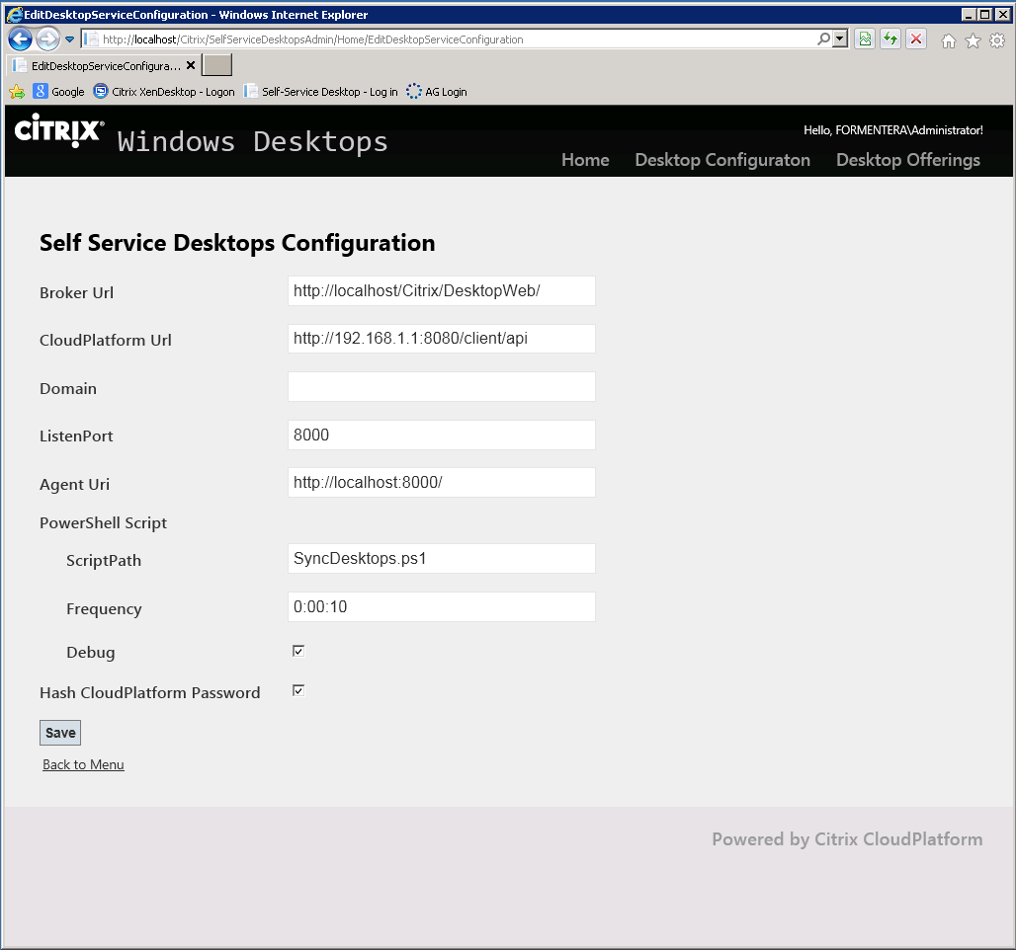

Hovering over a label (e.g. Broker Url) will give some help as to the use of the setting.

Press Save to save and apply any new settings – this will result in the configuration file being updated and the Self Service Desktops Agent restarted to read the new configuration.

Click on Back to Menu to return to the home page

Desktop Offerings

The second option Manage Desktop Offerings on the home page allows you to view the list of desktop offerings. You may also navigate to this page by using the Desktop Offerings button on the header bar.

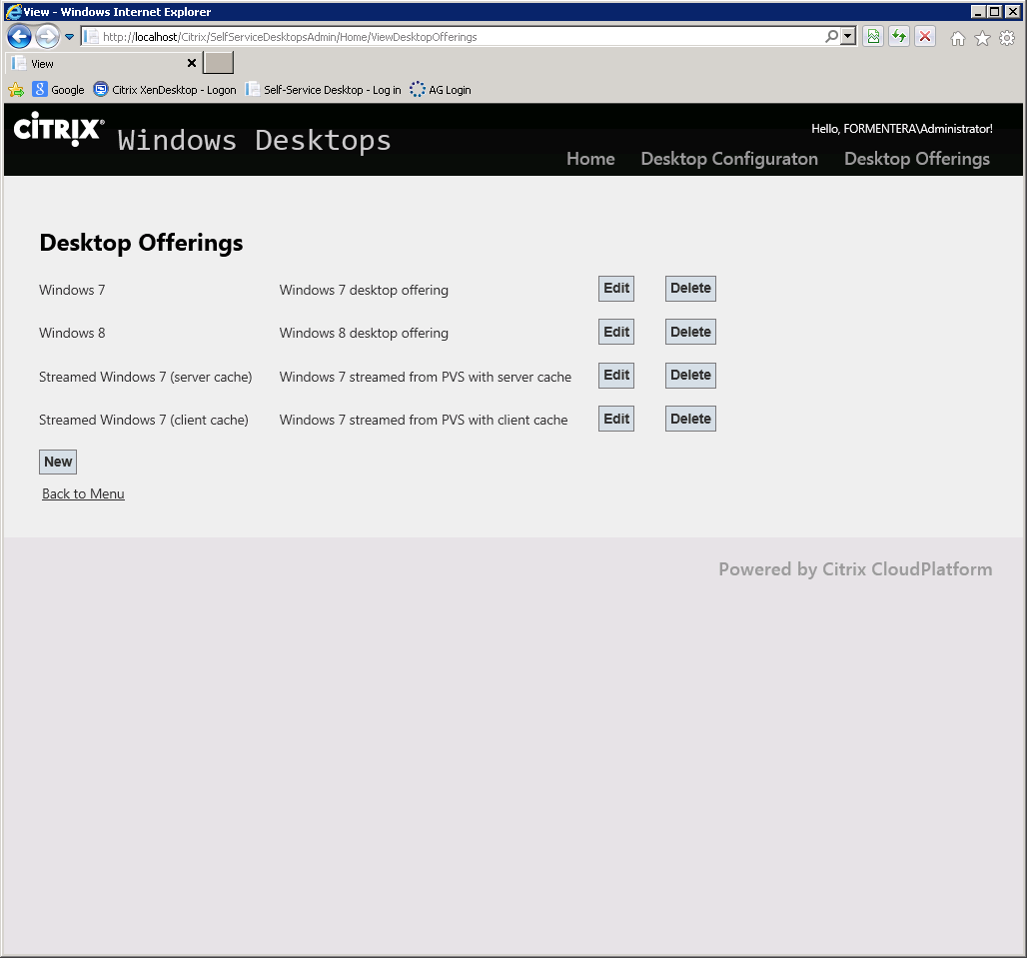

The name and description of the desktop offerings currently in the configuration will be displayed. Click Edit to view and optionally edit a desktop offering, Delete to remove a desktop offering from the configuration and New to create a new Desktop Offering.

Click on Back to Menu to return to the home page

The options New and Edit will result in the Edit Desktop Offering page being displayed as show below.

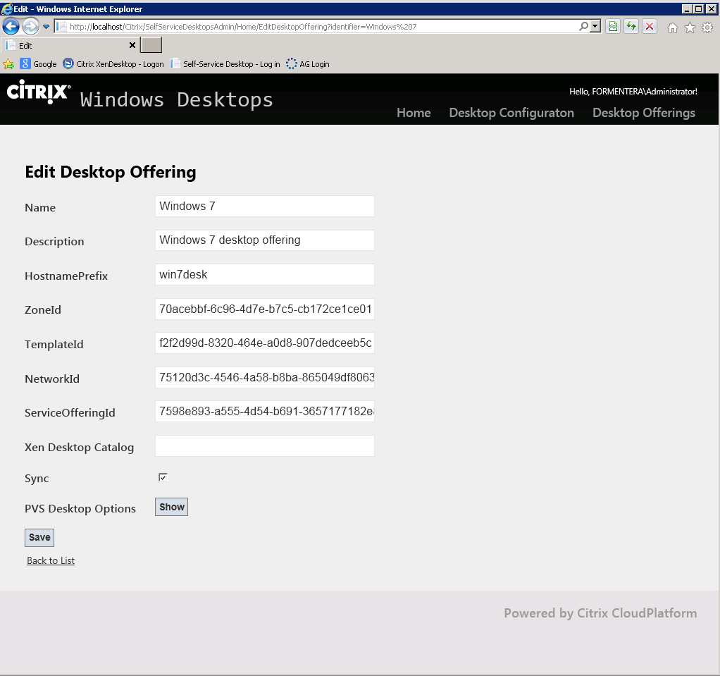

This page allows you to edit the configuration of a desktop offering.

To avoid clutter on the screen the extra options required for PVS desktops will be hidden if there are no values present. Press Show to display the PVS desktops options, Hide to remove them from display.

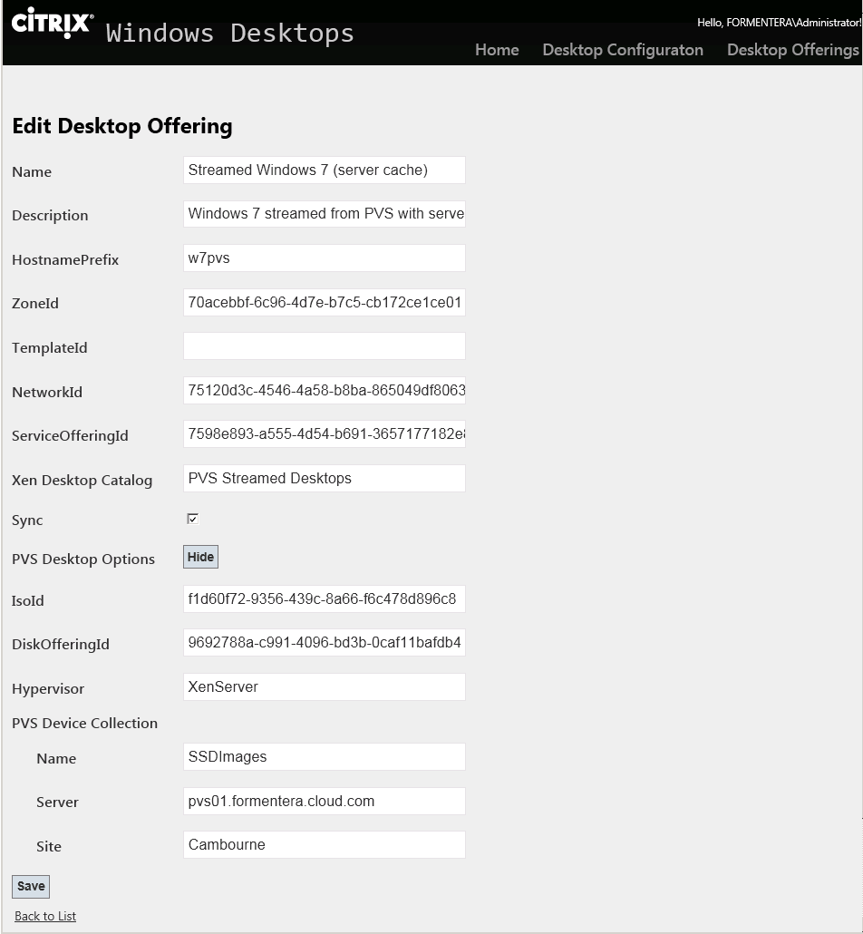

Hovering over a label (e.g. ZoneIdl) will give some help as to the use of the setting.

Press Save to save and apply any new settings – this will result in the configuration file being updated and the Self Service Desktops Agent restarted to read the new configuration.

Click on Back to Menu to return to the home page